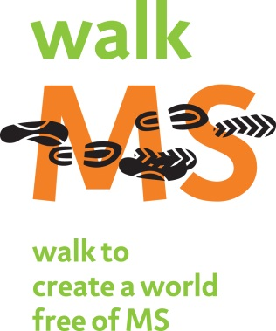
The Five that Drive
Five tips for Team Captains to kick start your team fundraising

- Register Yourself!
Walkers that register themselves raise more money! Get to know the online system at walkmsarizona.org!
- Make a Self Donation!
Once you’ve registered, make a donation to your team! Once you’ve made a contribution, it is easier to ask others to help you!
- Matching Gift Program!

Ask your employer if your company has a Matching Gift Program. You can easily double your donation!

- Boundless Fundraising!

Link your walk fundraising page to your social networks. By adding the Facebook application you can increase awareness about MS and your fundraising efforts.

- Utilize the Participant Center!

Use our online resources! Send emails to your contacts, check to see who has donated to your team, upload photos and videos and watch as your thermometer moves up closer to your team goal!

